Monster-Feast

Design Document

Group 2:

### Kalina Petrova (2221667)

### Raditya Pratama (2221796)

### Ishant Upadhyay (2309173)

### Class Ei8s2

### Mentor: Chung Kuah

Monster-Feast

Design Document

Group 2:

### Kalina Petrova (2221667)

### Raditya Pratama (2221796)

### Ishant Upadhyay (2309173)

### Class Ei8s2

### Mentor: Chung Kuah

2015

Table of Contents

Architecture Diagram 3

Description of Interfaces 3

**<<< Interface >>> ILobby** 3

**<<< Interface >>> ILobbyCallback** 4

**<<< Interface >>> IGame** 5

**<<< Interface >>> IGameCallback** 5

**<<< Interface >>> ILogin** 6

Class Diagram for Clients 7

Class Diagram for Services 0

Sequence Diagram 0

Create Match 0

Play Battle 1

Choose Character 2

Add Attribute Points 3

Register 4

Login 5

Database Model 6

# Architecture Diagram

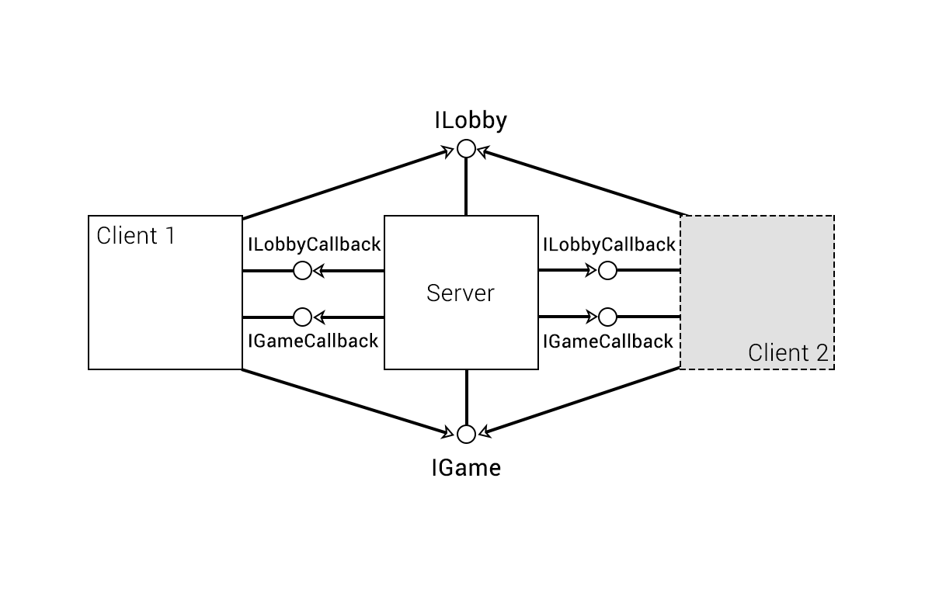

# Description of Interfaces

|  |  |  |  |
| --- | --- | --- | --- |
| **<<< Interface >>> ILobby** | | | |
| Methods | Description | Parameters | Return |
| + void FindMatch() | For finding match |  |  |
| + void sendMessage(string message, Player sender, DateTime time) | For sending chat message | Message: text message  Sender: the player who send the message  Time: time when the player send message |  |
| + void AllocateAttribute(Attribute a) |  | a:attribute name | Attribute points |
| + void SubscribeLobby() | For subscribe lobby |  |  |
| + void UnSubscribeLobby() | For unsubscribe lobby |  |  |
| + void SubscribeMatch(int roomNr) | For subscribing to specific room | roomNr: the number of the room where the battle will take place |  |
| + void UnsubscribeMatch(int roomNr) | For unsubscribing out of the match | roomNr: the number of the room it took place |  |
| + void SubscribeListPlayers() | For subscribe List of Players |  |  |
| + void UnSubscribeListPlayers() | For unsubscribe List of Players |  |  |
| +void getOnlinePlayer() | For the list of online player |  |  |
| +void getPlayer() | For getting the layer |  |  |
| +void sendChallenge(Player challenger,Player receiver) | For sending the challenge |  | Challenger and receiver |
| +void answerChallenge(Player challenger,Player receiver) | For answering the challenge |  | Challenger and receiver |
| + void createRoom(Player player,int rmNumber) | For creating to room to connect with opponent |  | Player ,rmNumber |
| +void joinRoom(Player player,int rmNumber) | For joining the room for the battle |  | Player, rmNumber |
| +string GetChatMessage() | To get the chat message |  |  |

|  |  |  |  |
| --- | --- | --- | --- |
| **<<< Interface >>> ILobbyCallback** | | | |
| Event | Description | Trigger | Parameters |
| + void updateChatBox(string message, Player sender, DateTime time) | Update chat box | When player send message | Message: text message  Sender: the player who send the message  Time: time when the player send message |
| + void updatePlayerList(Player p) | Update player list | When new player enter the lobby or leaving the lobby | P: Player |
| + void updateMatchList(List<Match>matches) | Updates the match list | When the list of match changes | matches- unique number of matches |
| + void updatePlayerInfo(Player user) | Updates the character information | When user adds attribute/skill points | user: the player whose character is being altered |
| +void ChallengeSent(string player1,string player2) | Send the challenge to opponent | When user click send challenge | Player1,player2 |
| +void ChallengeDenied(string player) | If the opponent want to denied the challenge | When opponent click denied the challenge | player |
| +void ChallengeAccepted(string player,Match match) | If the opponent denied the challenge | When the opponent accepted the challenge | Player,match |
| + void GameCreated(Player player1,Player player2,Match match,Player currentplayer) | Creates the game | When the player send the challenge and opponent accept the challenge |  |

|  |  |  |  |
| --- | --- | --- | --- |
| **<<< Interface >>> IGame** | | | |
| Methods | Description | Parameters | Return |
| + void attack(Skill a) | For player attack | a: Skill of player character |  |
| + void usePotion() | For regenerating health |  |  |
| + void giveUp() | For quit the game as giving up |  |  |
| + void sendMessage(string message, Player sender, DateTime time) | For sending chat message | Message: text message  Sender: the player who send the message  Time: time when the player send message |  |
| +void usePoint() | For upgrading the attribute |  |  |
| +void SubscribeMatch() | To play the game and also for getting update about match |  |  |
| +void unSubscribeMatch() |  |  |  |

|  |  |  |  |
| --- | --- | --- | --- |
| **<<< Interface >>> IGameCallback** | | | |
| Event | Description | Trigger | Parameters |
| + void OnGameStarted(Player opponent) | Shows the user information about his opponent | When a match room is created |  |
| + void OnGameOver(string message, int exp) | Event when the game is over | One of player hp is 0 or one of players gives up |  |
| + void updateBattleInfo(Player attacker, Player defender, Skill s, int damage) | Event when one of player finish the turn | When user confirms his attack |  |
| +void TurnStart() | The time where the player can make a move | When the player turn start. |  |
| +void TurnEnded() | The time where the player turn ends | When the player turn ends. |  |

|  |  |  |  |
| --- | --- | --- | --- |
| **<<< Interface >>> ILogin** | | | |
| Event | Description | Trigger | Parameters |
| + bool isRegistered(string username) | To check whether the player is registered or not | When a click login | username |
| + void Register(string username,string password) | To register the player | When player click register button | Username and password |
| + Player Login(string username,string password) | To login the player | When user click login button | Username and passeword |
| +void LogOut(string username) | To logout the player | When the player click logout button. | username |
| +bool hasChar(string username) | To check whether the player has character or not | When the player is logged In | username |
| + void createCharacter(int id,string name,CharClass charClass,Element element) | To create new character for player | When player select to create the character | Id,name,charClass,element |
| +void addToList(Player p) | To add the player to the list | When player in logged in | Player p |

# Class Diagram for Clients

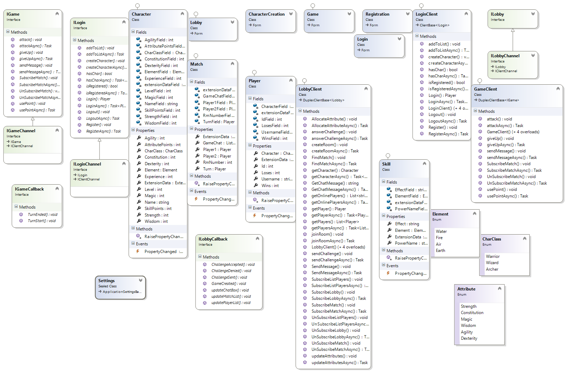

# Class Diagram for Services

# C:\Users\Ishant\Desktop\New game connect\More testing-Kalina\MonsterFeastService\ClassDiagram1.png

# Sequence Diagram

## Create Match



## Play Battle



## Choose Character



## Add Attribute Points



## Register



## Login



# Database Model

